**FRACTIONS**

What is a fraction?

A fraction is a part of a whole

**Naming fractions**

|  |  |  |
| --- | --- | --- |
| **We see** | **We write** | **We read** |
|  | 1 | One whole or a whole |
|  | ½ | One half or a half |
|  | ½ | One half or a half |
|  | 1/3 | One third or a third |
|  | ¼ | One quarter or a quarter |
|  |  | One fifth or a fifth |

**Naming fractions in words**

|  |  |  |  |
| --- | --- | --- | --- |
| **We have** | **We remove** | **We write** | **We read** |
| 4 equal parts | 1 part out of the 4 equal parts | ¼ |  |
| 4 parts | 3 parts out of the 4 parts | ¾ | Three quarters |
| 5 equal parts | 2 parts out of the 5 parts |  | Two fifths |
| 8 equal parts | 3 parts out of the 7 parts |  | Three sevenths |
| 9 equal parts | 4 parts out of the 9 parts |  | Four ninths |
| 5 equal parts | 1 part out of the 5 parts | 1/5 | One fifths |
| 8 equal parts |  | 1/8 | One eight or an eight |
| 10 equal parts | 1 part out of the 10 equal parts | 1/10 | One tenth or a tenth |

**Activity**

|  |  |  |  |
| --- | --- | --- | --- |
| **We have** | **We remove** | **We write** | **We read** |
| 3 cups | 1 cup out of the 3 cups | 1/3 |  |
| C:\Users\user2\Documents\My Documents\MY PHOTOZ\Luganda-BK1\Pencil.jpgC:\Users\user2\Documents\My Documents\MY PHOTOZ\Luganda-BK1\Pencil.jpgC:\Users\user2\Documents\My Documents\MY PHOTOZ\Luganda-BK1\Pencil.jpg  3 pencils | C:\Users\user2\Documents\My Documents\MY PHOTOZ\Luganda-BK1\Pencil.jpgC:\Users\user2\Documents\My Documents\MY PHOTOZ\Luganda-BK1\Pencil.jpg  2 pencils out of the 3 pencils | 2/3 | Two thirds |

**Comparing fractions**

**Examples**

**Use ‘greater than’ or ‘less than’ or equal**

|  |  |  |
| --- | --- | --- |
| Divide the first circle into 2 equal parts | Divide the second circle into 3 equal parts | Divide the third circle into 4 equal parts |
| ½ ½  ½ = ½ | 1/3  1/3 1/3  1/3  = | ¼ ¼    ¼ ¼    ¼ |

½ is greater than 1/3

½ is greater than ¼

1/3 is less than ½

¼ is less than ½

**Exercise**

**Use greater than or less than**

1. 1/3 is …………………… ½
2. ½ …………………1/3
3. 1/3 is …………… ¼
4. ¼ is ………….1/3
5. 1/3 is …………….1/6
6. ¼ is …………….. 1/6
7. 1/8 is ……………1/7
8. 1/8 is ……………1/10
9. 1/10 is …………..1/9
10. 1/7 is ……………1/10

A new M.K Primary MTC pupils bk 3 Page 99 – 100

A new M.K P.3 MTC pupils bk 3 page 97 – 98

**Writing the shaded and unshaded fractions.**

Examples

1 of the 2 parts shaded = ½

1 of the 2 parts unshaded = ½

**5 of the 8 parts shaded = 5/8**

**3 of the 8 parts unshaded = 3/8**

**Exercise**

**What fraction is shaded and unshaded?**

**shaded fraction ……………………….**

**unshaded fraction ……………………**

**Shaded fraction ……………………..**

**Unshaded fraction …………………**

Shaded fraction…………………………

Unshaded fraction ………………………

Shaded fraction …………………..

Unshaded fraction …………………

Shaded fraction ……………………….

Unshaded fraction …………………….

Shaded fraction …………………….

Unshaded fraction ………………….

Shaded fraction……………………

Unshaded fraction………………….

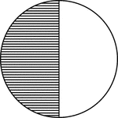

Shaded fraction………………….

Unshaded fraction………………

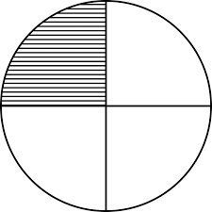

Shaded fraction…………………….

Unshaded fraction…………………

**Addition of fractions with the same denominators**

**Examples**

1. Add 4 + 3

8 8

4 + 3 = 4 + 3 = 7

8 8 8 8

1. Add: 2 + 1

2 + 1 = 2 + 1 = 3

6 6 6 6

1. Add: 3 + 1

4 4

3 + 1 = 3+1 = 4 = 1

4 4 4 4

**Exercise**

**Add the following fractions**

1. 1 + 1

4 4

1. 1 + 1

8 8

1. 1 + 2

5 5

1. 5 + 3

9 9

1. 1 + 2

6 6

1. 2 + 3

7 7

1. 5 + 2

8 8

1. 4 + 2

15 15

**More addition of fractions**

**Examples**

1. 1 + 1

2 2

1 + 1 = 1 + 1 = 2 = 1

2 2 2 2

1. 1 + 1 + 1 = 1 + 1 + 1 = 3

5 5 5 5 5

1. 1 + 3 + 1 = 1 + 3 + 1 = 5

8 8 8 8 8

**Activity**

**Add the following fractions**

1. 1 + 2

4 4

1. 1 + 1

3 3

1. 2 + 1 + 2

8 8 8

1. 1 + 1 + 1

9 9 9

1. 1 + 2 + 3

6 6 6

1. 1 + 2 + 4

7 7 7

1. 1 + 2 + 3

10 10 10

1. 2 + 2 + 3

12 12 12

1. 1 + 4

8 8

1. 1 + 2 + 4

15 15 15

**Word applications involving addition of fractions**

**Examples**

1. A pupil read 1/8 of the book on Monday and 3/8 of it on Tuesday. What fraction did the pupil read altogether?

1 + 3 = 1 + 3 = 4

8 8 8 8

1. Find the sum of 4 and 2

11 11

4 + 2 = 4 + 2 = 6

11 11 11 11

**Exercise**

1. Find the sum of 7 and 4

15 15

1. I walked 4 of the journey and I ran 3 of it. What fraction did I cover altogether?

9 9

1. Jane dug 3 of ate garden and Deo dug 4. What fraction did they dig altogether?

10 10

1. Musa ate 7 of the cake and Namuga ate 4 of the cake. What fraction of the cake did they eat?
2. If 1 of the school garden is covered with maize and 2 with beans. What fraction is covered with both crops?

4 4

1. Andrew wrote 3 of the book in the morning and 4 of it in the evening. What fraction of the book did he write?

8 8

1. A child walked 3 of the journey and are ran 5 of the journey. What fraction of the journey did the child cover?

11 11

1. A teacher marked 2 of the books in the morning and 3 in the afternoon. What fraction of the books did the

5 5

Teacher mark?

**Subtraction of a fraction for a whole number**

**Examples**

1. 1 – 3

5

4 – 3 = 4 – 3 = 1

4 4 4 4

1. Subtract 1 – 3

8

8 – 3 = 8 – 3 = 5

**8 8 8 8**

**Exercise**

**Subtract the following numbers**

1. 1 – 3

7

1. 1 – 4

5

1. 1 – 2

7

1. 1 – 5

9

1. 1 – 6

10

1. 1 – 7

10

1. 1 – 2

5

1. 1 – 5

8

**Subtraction of fractions with the same denominators**

**Examples**

1. Subtract: 4 – 1

5 5

4 – 1 = 4 – 1 = 3

5 5 5 5

1. Subtract: 3 – 1

6 6

3 – 1 = 3 -1 = 2

6 6 6 6

**Exercise**

1. 2 – 1

3 3

1. 4 – 1

5 5

1. 3 – 1

4 4

1. 5 – 2

6 6

1. 7 – 1

10 10

1. 11 – 5

16 16

1. 9 – 2

20 20

1. 11 – 3

21 21

1. 5 – 2

7 7

1. 7 – 4

15 15

**Word application involving subtraction of fractions**

**Examples**

1. A boy had 5 of a cake. He ate 2 of it. What fraction remained?

6 6

5 – 2 = 5 – 2 = 3

6 6 6 6

1. A girl had an orange. She gave away 3 of it. What fraction remained?

4

1 – 3

4

4 – 3 = 4 – 3 = 1

4 4 4 4

**Exercise**

1. A garden had 8 equal parts. 3 parts out of 8 are planted with maize. What fraction remained?
2. John painted 7 of his house on Monday. What fraction of his house had not been painted?

10

1. Fausta ate 4 of an orange. What fraction remained?

5

1. A child used 3 of the water in the jerrycan for bathing. What fraction was left?

20

1. After travelling 3 of the journey. What fraction is left for me to cover?

7

1. A bowl was 11 full of sugar. I used 5 of it. What fraction was left?

12 12

1. What is the difference between 11 and 6?

12 12

1. A pupil did 5 of his homework. What fraction of the home work was left?

9

**More subtraction in word application**

**Examples**

1. What is the difference between 5/7 and 3/7?

5/7 - 3/7 = 5 – 3 = 2/7

7

1. James ate 3/9 of a cake in the morning. What fraction remained?

3/9 = 9/9 = 9 – 3 = 6

9 9

**Activity**

1. A bowl was 11 full of sugar. I used 5/12 of it. What fraction was left?
2. What is the difference between 11 and 6?

12 12

1. A pupil did 5 of his homework. What fraction of the homework was left?

9

1. Remove 5 and 11?

16 16

**Multiplication of fractions**

**Examples**

1. Multiply 2. Multiply

1 x 1 2 x 1

2 3 5 4

= 1 x 1 2 x 1

2 3 5 x 4

= N x W = 2

D x D 20

= 1 x 1

2 x 3

= 1

6

**Exercise**

**Multiply the following fractions**

1. 1 x 1

2 4

1. 1 x 2

3 5

1. 2 x 1

3 2

1. 3 x 4

4 2

1. 2 x 3

6 4

1. 1 x 1

3 4

1. 2 x 2

7 3

1. 1 x 1

2 2

**Multiplication of Fractions and whole numbers**

**Examples**

1. What is ½ of 6?

= ½ x 6

=(1x6) ÷2

= 6÷2

= 3

1. What is 2 of 12 pens?

3

= 2 x 12

3

= (2x12) ÷ 3

= 24 ÷ 3

= 8

**Exercise**

1. What is ½ of 8?
2. What is 1 of 9?

9

1. What is 2 of 9 goats?

3

1. Workout ½ of 24 books?
2. What is 2 of 10?

5

1. What is ¼ of 8?
2. What is 2 of 18 pencils?

3

1. What is ½ of 30 eggs?

**Word application involving fractions of wholes**

**Examples**

1. Musa had 10 books. If thieves stole ½ of them, how many books did they steal?

½ of 10 books

½ x 10 books

= (1x10) ÷ 2

= 10 ÷ 2

= 5 books

1. Sarah has 12 oranges. She gave away 2/3 of her oranges to her friend. How many oranges did she give away?

2 of 12 oranges

3

2 x 12 oranges

3

= (2x12) ÷ 3

= 24 ÷ 3

= 8 oranges

She gave away 8 oranges.

**Exercise**

1. Tom has 8 eggs. He gave away ½ of them, how many eggs did he give away.
2. What is ½ of 18 tomatoes?
3. Joy has 12 pencils. 1/3 of them was stolen. How many pencils were stolen?
4. A man had 48 cows. He gave away ½ of them, how many cows did he give away?
5. What is 2 of 15 books?

3

**Decimal**

**Example**

1 = a tenth

10

2 = 0.2

10

**Exercise**

**Change the following fractions to decimals.**

1. 1

10

1. 2

10

1. 3

10

1. 8

10

1. 7

10

1. 4

10

1. 6

10

1. 9

10

**Addition of decimals**

**Examples**

1. Add: 0.2 + 0.3

0 . 2

+ 0 . 3

0 . 5

1. Add:

5 . 2

+ 1 . 4

6 . 6

**Exercise**

**Add the following fractions**

1. 4 . 2

+ 1 . 5

5 . 6

1. 2 . 0

+ 1 . 4

1. 6 . 1

+ 5 . 2

1. 0 . 2 1

+ 0 . 7 3

1. 1 2 . 4

+3 . 9

1. 1 3 . 7

+2 0 . 7

**Word application involving addition of decimals**

**Examples**

1. Musa had 0.5kg of sugar. He was added 0.2kg of sugar. How much sugar did he have altogether?

0 . 5kg

+ 0 . 2kg

0 . 7kg

1. A man had 4.5 litres of water. He got 2.4 litres more. How many litres did have altogether?

4 . 5 litres

+ 2 . 4 litres

6 . 9 litres

**Exercise**

1. Find the sum of 0.4 and 0.5.
2. A girl had 2.5 litres of milk. Her mother added her 1.2 litres of milk. How many litres did he have altogether?

**Subtraction of decimals**

**Examples**

1. Subtract:

0 . 9

* 0 . 5

0 . 4

1. Subtract 2 . 8 – 1 . 3

2 . 8

* 1 . 3

1.5

**Exercise**

**Subtract the following decimals.**

1. 0 . 7

- 0 . 2

1. 0 . 6 5

+ 0 . 2 1

1. 0 . 81

- 0 . 21

1. 5 . 9

- 2 . 1

1. 8 . 4

- 5 . 4

1. 1 4 . 7

- 1 . 4

**Money**

Money is any form of exchange

In Uganda we use shillings i.e. notes and coins

**Addition of money**

**Examples**

1. Sh. 200 + sh. 150 =

sh. 200

sh. +150

sh. 350

1. sh. 750 + sh. 500 + sh. 50

Sh. 7 5 0

Sh. 5 0 0

sh. 1 3 0 0

**Exercise**

**Add the following correctly**

1. Sh. 150 + shs. 50
2. sh. 400 + shs. 200
3. Sh. 200 + sh. 250
4. sh. 700 + sh. 450
5. Sh. 500 + sh. 250
6. Sh. 400 + sh. 150
7. sh. 200 + shs. 100
8. Sh. 300 + sh. 350
9. Sh. 5 0 0 10. sh. 2 0 0

5 0 0 1 5 0

+3 5 0 + 2 0

**Addition of money in word application**

**Examples**

1. Dad gave me sh. 1050 in the morning and in the evening he gave me sh. 750. How much money did he give me altogether?

sh. 1 0 5 0

sh. + 7 5 0

1. I had sh. 100. My mother gave me sh. 50 more. How much money do I have now?

Sh. 1 0 0

Sh. + 5 0

sh. 1 5 0

**Exercise**

1. Namusisi had sh. 600. Her friend gave her sh. 500 more. How much money does she have now?
2. Ada has sh. 400, Apio has sh. 350 and Auma has sh. 500. How much money do they have altogether?
3. Akiiki has sh. 750. Her friend gave her sh. 200. How much money does she have altogether?
4. Musoke has sh. 250. He was given another sh. 200. How much money had he altogether?
5. I had sh. 1000. My friend gave me sh. 50 more. How much money do I have now?
6. A trader has sh. 500. He sells his oranges for sh. 400. How much money has he now?

**Subtraction of money**

**Examples**

1. Subtraction: sh. 500 – sh. 400

sh. 500

* sh. 400

sh. 100

1. Sh. 800

sh. 350

sh. 450

1. Sh. 2000

sh. -1700

sh. 0300

**Exercise**

1. Sh. 400 – sh. 150
2. Sh. 1500 – sh. 300
3. Sh. 700 – sh. 350
4. sh. 900 – sh. 700
5. sh. 800 – sh. 450
6. sh. 400 – sh. 150
7. sh. 7 0 0

sh. 2 0 0

1. sh. 1 0 5 0

sh. – 8 0 0

1. sh. 1 4 5 0

sh. – 1 0 0 0

1. sh. 1 8 5 0

sh. – 2 5 0

**Subtraction of money in word applications**

**Examples**

1. Omong had sh. 9800 and he spent sh. 3500 on food. How much money did he remain with?
2. Mugoya had sh. 2550. He lost sh. 500. How much money reamiend?
3. Lillian was given sh. 5000. She bought a book at sh. 4200. How much money remained?
4. My mother had sh. 500. She gave me sh. 200. How much money did she remain with?
5. David had sh. 6750. He gave sh. 2870 to his young sister. How much did he remain with?
6. Susan spent sh. 7300 on her trip to the National park. If she had sh. 900 altogether, how much money was she left with?
7. Carol had sh 3500. She gave us sh. 2450. How much money did she remain with?

**Multiplication of money**

**Examples**

1. Multiply

Sh. 5 0 0

x 5

sh. 2 5 0 0

2. Find the cost of 6 exercise books, if one books costs shs. 320.

1 book costs sh. 320

6 books will cost

sh. 320

x 6

sh. 1920

**Exercise**

1. A pencils costs sh. 700. How much will I pay for 4 pencils?
2. A piece of soap costs sh. 150. What will be the cost of 5 pieces?
3. Kapere bought 4 belts at sh. 2400 each. How much did he pay?
4. A kilogram of beans costs sh. 600. How much will mother pay for 6 kilograms?
5. A pineapple costs sh. 250. How much money will Mikka pay for 3 pineapples?
6. One tin of groundnuts costs sh. 100. How much money will father spend on 4 tins?
7. One cup cots sh. 200. How much money will Kide pay for 4 cups?
8. An onion costs sh. 50. How much money will Ruth pay for 6 onions?

**Shopping**

**Example**

**Use the following bill below to answer the questions that follow**

|  |  |
| --- | --- |
| Item | Cost |
| Sugar | Sh. 20000 |
| Pencil | Sh. 200 |
| Blue band | Sh. 1800 |
| rice | Sh. 3000 |

1. How much will Ritah pay for 2kgs of sugar?

1kg = sh. 2000

2kg = sh. 2000

x 2

sh. 4000

1. Calculate the cost of 4 pencils.

1 pencil = sh. 200

4 pencils = sh. 200

x 4

sh. 800

1. How much will Daniel pay for Rice and a tin of blue band?

Rice = Sh. 3000

Blue band = sh. + 1800

sh. 4800

**Exercise**

The learners do written exercises from the text books

Exercise 16g on page 181

Exercise 16h on pages 182 – 183

Exercise 161 on page 184

**Division of money**

**Example**

1. Mr. Kisuule had sh. 800 and he bought 4 pencils. How much did each pencil cost?

4 pencils cost sh. 800

1 pencil costs sh. 800

4

200

4 800

800

00

1 pencil got sh. 1900

1. Ataliba had sh. 9500. She shared it equally among 5 boys. How much did each boy get?

5 boys share ………………..sh. 9500

1 boy got …………………….sh. 9500

5

1900

5 9500

-5

45

45

00

00

1 boy got sh. 1900

**Exercise**

1. Katabira shared sh. 600 equally among 3 children. How much did each child get?
2. Kaliisa had sh. 1500. He shared it among his 5 friends. How much did each get?
3. 8 workers shared sh. 3200. How much money did each of them get?
4. Nakalanzi had sh. 860. She shared it between her two brothers. How much did each get?
5. Kabagambe had sh. 2500. He shared it equally among 5 boys. How much did each get?
6. Ten porters shared 4800/=. How much did each get.

**Polygons**

A polygon is any enclosed figure with sides

**Examples**

1. **Square**

**Properties**

- It had four sides equal

- It has four right angles

1. **Rectangle**

**Properties**

- It has four sides with 2 opposite sides equals

- It has four right angles

1. **Triangle**

**Properties**

- It has three sides

- It has three angles

Other polygons

kite pentagon Hexagon

**Solid shapes Triangular pyramid**

(tetrahedron)

cone cuboid

cylinder

cube

**Exercise**

1. Learners will draw polygons correctly
2. Parts of a cube and a cuboid

vertex

face

edge

1. How many vertices does a cuboid/cube have?
2. How many faces does a cube/cuboid have?
3. How many edges does cuboid/cube have?
4. Identify different shapes dorm the given diagram.
5. How many triangles can you see?

**Graphs and interpretation of information**

**Pictographs**

When using pictographs, one picture stands for a given number of pictures.

**Examples**

The pictograph below shows the number of books given to five best pupils in different games.

Study it and use it to answer the questions that follow.

|  |  |
| --- | --- |
| Moses | C:\Users\user2\Documents\My Documents\MY PHOTOZ\Luganda-BK1\Book.jpgC:\Users\user2\Documents\My Documents\MY PHOTOZ\Luganda-BK1\Book.jpgC:\Users\user2\Documents\My Documents\MY PHOTOZ\Luganda-BK1\Book.jpg |
| Alex | C:\Users\user2\Documents\My Documents\MY PHOTOZ\Luganda-BK1\Book.jpg |
| Josephine | C:\Users\user2\Documents\My Documents\MY PHOTOZ\Luganda-BK1\Book.jpgC:\Users\user2\Documents\My Documents\MY PHOTOZ\Luganda-BK1\Book.jpgC:\Users\user2\Documents\My Documents\MY PHOTOZ\Luganda-BK1\Book.jpgC:\Users\user2\Documents\My Documents\MY PHOTOZ\Luganda-BK1\Book.jpgC:\Users\user2\Documents\My Documents\MY PHOTOZ\Luganda-BK1\Book.jpg |
| John | C:\Users\user2\Documents\My Documents\MY PHOTOZ\Luganda-BK1\Book.jpgC:\Users\user2\Documents\My Documents\MY PHOTOZ\Luganda-BK1\Book.jpgC:\Users\user2\Documents\My Documents\MY PHOTOZ\Luganda-BK1\Book.jpg |
| Hannah | C:\Users\user2\Documents\My Documents\MY PHOTOZ\Luganda-BK1\Book.jpgC:\Users\user2\Documents\My Documents\MY PHOTOZ\Luganda-BK1\Book.jpgC:\Users\user2\Documents\My Documents\MY PHOTOZ\Luganda-BK1\Book.jpgC:\Users\user2\Documents\My Documents\MY PHOTOZ\Luganda-BK1\Book.jpg |

Scale

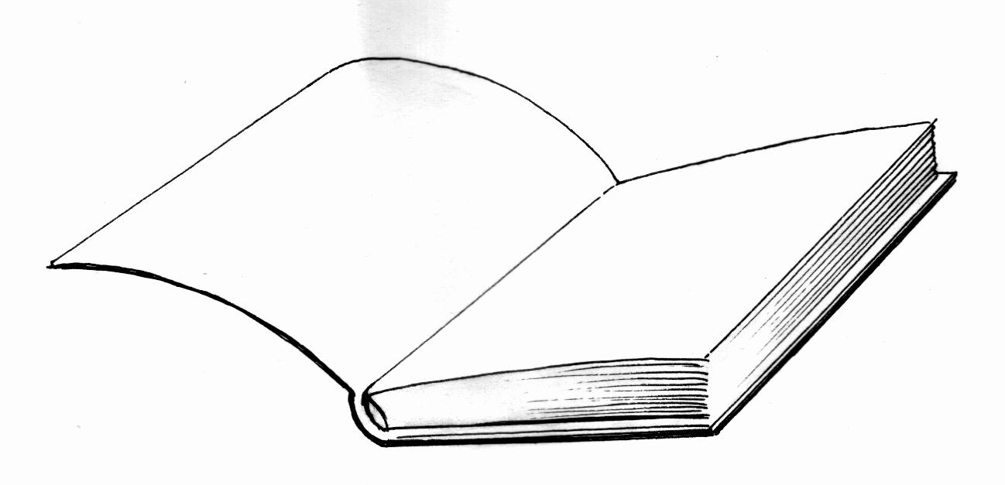stands for 10 books

1. How many stands for 10 books

1 pictures stands for 10 books

5 pictures stand for (5x10) books

= 50 books

**Josephine got 50 books**

1. How many books did Moses get?

Moses got 910 + 10 + 10) books

= 30 books

1. How many more books did Hanah get than Alex?
2. Who got the least number of books?
3. Who got 40 books?
4. Who got the highest number of books?
5. How many books did John and Moses get altogether?
6. How many books were given out altogether?

**Activity**

The graph below shows the number of bottles of soda sold in Bagambe’s shop in a week. Study in and answer the questions that follow;

|  |  |
| --- | --- |
| Monday | C:\Users\user2\Documents\My Documents\MY PHOTOZ\Luganda-BK1\Bottle.jpgC:\Users\user2\Documents\My Documents\MY PHOTOZ\Luganda-BK1\Bottle.jpg |
| Tuesday | C:\Users\user2\Documents\My Documents\MY PHOTOZ\Luganda-BK1\Bottle.jpgC:\Users\user2\Documents\My Documents\MY PHOTOZ\Luganda-BK1\Bottle.jpgC:\Users\user2\Documents\My Documents\MY PHOTOZ\Luganda-BK1\Bottle.jpgC:\Users\user2\Documents\My Documents\MY PHOTOZ\Luganda-BK1\Bottle.jpg |
| Wednesday | C:\Users\user2\Documents\My Documents\MY PHOTOZ\Luganda-BK1\Bottle.jpgC:\Users\user2\Documents\My Documents\MY PHOTOZ\Luganda-BK1\Bottle.jpgC:\Users\user2\Documents\My Documents\MY PHOTOZ\Luganda-BK1\Bottle.jpg |
| Thursday | C:\Users\user2\Documents\My Documents\MY PHOTOZ\Luganda-BK1\Bottle.jpgC:\Users\user2\Documents\My Documents\MY PHOTOZ\Luganda-BK1\Bottle.jpgC:\Users\user2\Documents\My Documents\MY PHOTOZ\Luganda-BK1\Bottle.jpgC:\Users\user2\Documents\My Documents\MY PHOTOZ\Luganda-BK1\Bottle.jpgC:\Users\user2\Documents\My Documents\MY PHOTOZ\Luganda-BK1\Bottle.jpgC:\Users\user2\Documents\My Documents\MY PHOTOZ\Luganda-BK1\Bottle.jpgC:\Users\user2\Documents\My Documents\MY PHOTOZ\Luganda-BK1\Bottle.jpg |
| Friday | C:\Users\user2\Documents\My Documents\MY PHOTOZ\Luganda-BK1\Bottle.jpgC:\Users\user2\Documents\My Documents\MY PHOTOZ\Luganda-BK1\Bottle.jpgC:\Users\user2\Documents\My Documents\MY PHOTOZ\Luganda-BK1\Bottle.jpgC:\Users\user2\Documents\My Documents\MY PHOTOZ\Luganda-BK1\Bottle.jpgC:\Users\user2\Documents\My Documents\MY PHOTOZ\Luganda-BK1\Bottle.jpgC:\Users\user2\Documents\My Documents\MY PHOTOZ\Luganda-BK1\Bottle.jpg |
| Saturday | C:\Users\user2\Documents\My Documents\MY PHOTOZ\Luganda-BK1\Bottle.jpgC:\Users\user2\Documents\My Documents\MY PHOTOZ\Luganda-BK1\Bottle.jpgC:\Users\user2\Documents\My Documents\MY PHOTOZ\Luganda-BK1\Bottle.jpgC:\Users\user2\Documents\My Documents\MY PHOTOZ\Luganda-BK1\Bottle.jpg |

Scale

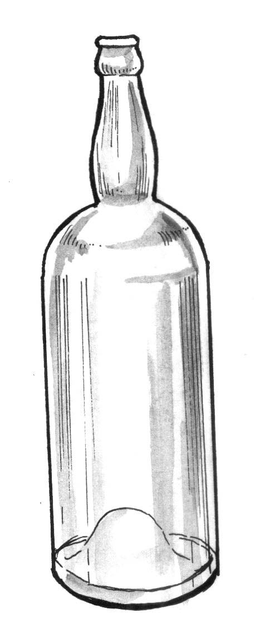Stands for 20 bottles

Each bottle stands for 20 bottles

1. How many bottles were sold on Tuesday?
2. On which day was the smallest number of bottles sold?
3. How many bottles were sold on Friday?
4. On which two days was the same number of bottles sold?
5. On which day did Bagambe sell 60 bottles of soda?
6. How many bottles were sold for the last two days?
7. How many more bottles were sold on Friday than Tuesday?
8. Find the total number of bottles sold for the whole week.

**Drawing simple pictographs**

Five girls were told to pick flowers form the garden and each picked the following

Rose picked 12 flowers

Jamilu picked 6 flowers

Anne picked 4 flowers

Sarah picked 10 flowers

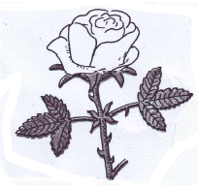Sarah picked 12 flowers

Key stands for 2 flowers

|  |  |
| --- | --- |
| Rose |  |
| Jamulu |  |
| Anne |  |
| Felix |  |
| Sarah |  |

Rose = 12 ÷ 2 = 6 flowers

Jamilu 6 ÷ 2 = 3 flowers

Anne 4 ÷ 2 = 2 flowers

Felix 10 ÷ 2 = 5 flowers

Sarah 12 ÷ 2 = flowers

**Activity**

Given that represents 10 balls, draw a picture graph to represent the number of balls given to the five streams of P.3.

P.3N received 40

P.3P received 50

P.3S received 10

P.3M received 40

P.3B received 20

**Column graphs/Bar graphs**

Information can also be represented in from of the graph below

Count spaces upwards to get the answer

**Example**

A headteacher asked 5 pupils in P.3P tp carry boxes to his office. Study and use it to answer the questions that follow.

100

90

80

70

60

50

40

30

20

0

Nyariak Gatek Hope Esther Angle

Names o f pupils

1. How many pupils carried boxes?
2. Who carried the least number of boxes?
3. Who carried the largest number of boxes?
4. Who carried the same number of boxes?
5. What is the difference between the largest and least number of boxes?
6. How many boxes did Gatek and Esther carry all altogether?
7. IF each box had 5 books, how many books did Nyariak carry?
8. How many more boxes did Hope carry tan Easter?
9. Who carried 70 boxes?
10. Find the number of boxes carried out by the five pupils altogether?

**Activity**

**Study the graph below showing boxes carried by six children**

10

9

8

**Number of boxes**

7

6

5

4

3

2

1

0

Amos Appollo Anita Annet Alice Allen

Name of pupils

1. How many boxes did Amos carry?
2. How many more boxes did Apollo carry than Anita?
3. Who carried the least number of boxes?
4. Find the total number of boxes of the six children carried.

**Study the graph below. It shows the daily attendance of P.3N in a certain week**

60

**Number of pupils**

50

40

30

20

10

0

Mon Tue Wed Thur Fri

Days of the week

1. How many pupils are there in the class?
2. How many pupils attended on Wednesday?
3. Which days have the same number of pupils attended?
4. Find the difference between the highest and the lowest attendance.
5. How many pupils were absent on Friday?
6. Find the total attendance of the week.